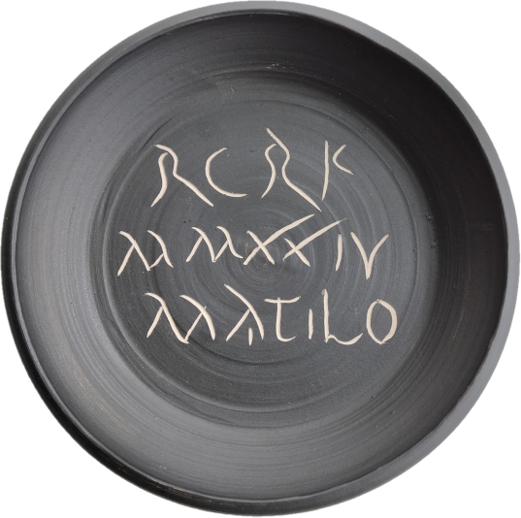
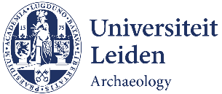


33rd Congress of the Rei Cretariæ Romanæ Fautores
Leiden, the Netherlands, 15-22 September 2024

(CULTURAL) CONTACTS & CERAMIC CONTEXTS

Registration Form (Registration deadline: 31 March 2024)

PERSONAL & PROFESSIONAL DATA*
Surname
First name
Title
Affiliation/Institution
Address and Postal Code
City and Country
Email address
Telephone number
I wish to attend the closing dinner | Yes/No (delete accordingly)
Dietary restrictions | To best organise the lunches, please indicate any dietary restrictions here, if any:

PARTICIPATION
I wish to participate with a | Presentation/Poster/I will participate without presentation or poster (delete accordingly)
Co-authors (in case of multiple authors, we kindly request that each author who will participate in the conference in person fills in a separate registration form)
Title
Abstract (max. 200 words)

POST-CONGRESS EXCURSIONS
Would you like to participate in the post-congress excursion(s) to?
Nijmegen (Saturday 21) | Yes/No (delete accordingly)
Utrecht and environs (Sunday 22) | Yes/No (delete accordingly)

GRANTS FROM THE RCRF TRUST
Would you like to apply for a grant from the RCRF Trust for financial support in case your abstract is accepted?
Yes/No (delete accordingly)

* Privacy policy: in line with the Algemene Verordening Gegevensbescherming (AVG), the Dutch law which regulates the storing and keeping of personal data, your personal and professional data will be stored for the duration of the congress. These data will not be shared with any other institution.

